Random Forest Tutorial: A Comprehensive Guide

1. Introduction
Machine learning has revolutionized data-driven decision-making, providing advanced tools to solve complex problems. Among these tools, Random Forest stands out for its versatility, robustness, and ability to handle a wide variety of datasets effectively. It is one of the most popular algorithms used for both classification and regression tasks, making it an essential component of every data scientist’s toolkit.
What is Random Forest?
Random Forest is an ensemble learning technique that builds multiple decision trees during training and combines their predictions to achieve higher accuracy and reduce overfitting. This approach is based on two key principles:
- Bagging (Bootstrap Aggregating): Randomly selects subsets of the training data with replacement to create diverse trees.
- Random Feature Selection: Each tree is allowed to consider only a random subset of features at each split, further increasing diversity among the trees.
The combined predictions of these diverse trees result in a model that is:
- Less prone to overfitting compared to individual decision trees.
- Highly accurate due to aggregation.
Why Use Random Forest?
Random Forest is favoured for several reasons:
- Accuracy and Robustness: By aggregating predictions from multiple trees, it provides reliable and stable results.
- Versatility: It works well for both numerical and categorical data, handling regression and classification tasks with ease.
- Feature Importance: Offers insights into which features contribute most to predictions, aiding feature selection and data preprocessing.
- Resilience to Noise: Reduces the impact of outliers or noisy data by relying on multiple models rather than a single decision tree.
This tutorial demonstrates how to implement Random Forest using Python, evaluate its performance with various metrics, optimize it through hyperparameter tuning, and interpret the results using feature importance and decision boundary visualizations.

2. Dataset Overview
The Iris Dataset
The Iris dataset, introduced by Ronald A. Fisher in 1936, is a classic dataset often used for exploring classification algorithms. It contains 150 samples of iris flowers, divided into three species:
- Setosa
- Versicolor
- Virginica
Each sample is characterized by the following features:
- Sepal Length (cm)
- Sepal Width (cm)
- Petal Length (cm)
- Petal Width (cm)
Our task is to predict the species of an iris flower based on these measurements.
Dataset Summary
- Features: 4
- Classes: 3 (Setosa, Versicolor, Virginica)
- Samples: 150
- Problem Type: Multiclass classification
The dataset is balanced, with 50 samples per class, making it ideal for demonstrating the Random Forest algorithm.
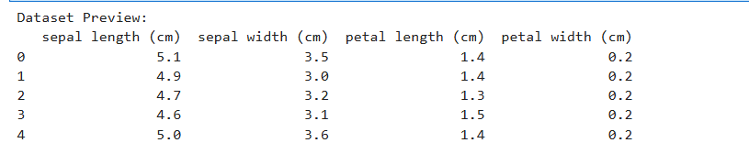

Citation:
Fisher, R. A. (1936). The Use of Multiple Measurements in Taxonomic Problems. Annals of Eugenics, 7(2), 179–188. doi:10.1111/j.1469-1809.1936.tb02137.x

3. Setting Up the Environment
To implement and evaluate the Random Forest algorithm, you will need the following Python libraries:
- pandas: For data manipulation and preprocessing.
- numpy: For numerical computations.
- matplotlib and seaborn: For creating visualizations.
- scikit-learn: For machine learning models and utilities.
Install these libraries by running:
pip install pandas numpy matplotlib seaborn scikit-learn
Once the libraries are installed, you are ready to begin the implementation.

4. Building the Random Forest Model
Step 1: Data Preprocessing
The first step is to load the Iris dataset from scikit-learn and split it into training and testing sets. This ensures that we have a separate dataset to evaluate the model's performance after training. We use a 70-30 split, with 70% of the data for training and 30% for testing.
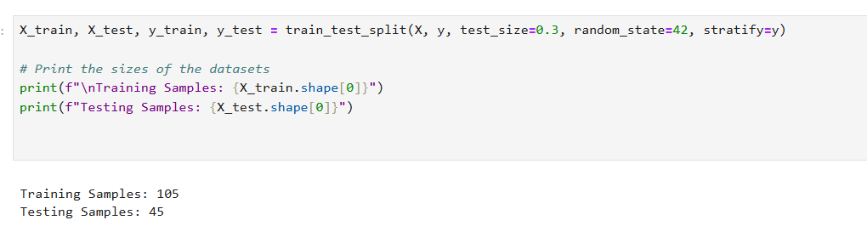

Step 2: Baseline Model
To establish a reference point, we train a Random Forest classifier using default parameters. This serves as the baseline model.
Evaluation Metrics
The baseline model's performance is evaluated using the following metrics:
- Accuracy: The proportion of correctly classified samples.
- Confusion Matrix: A matrix that shows the actual vs. predicted classes for all samples.
- Classification Report: A detailed summary of precision, recall, and F1-score for each class.
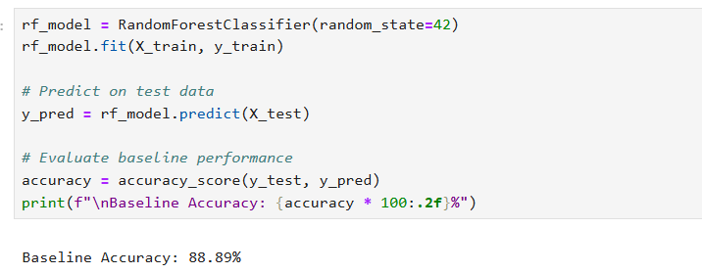

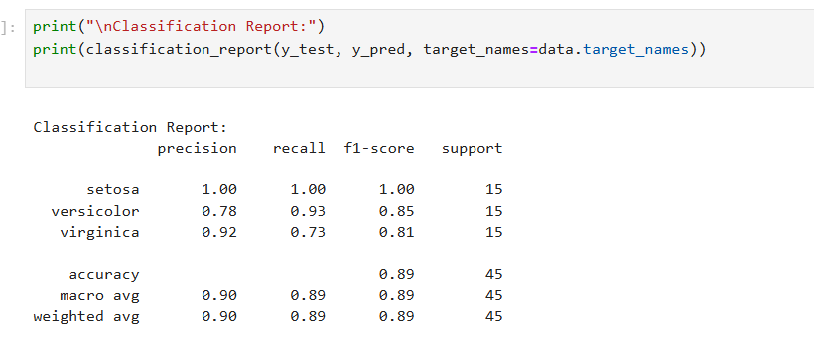

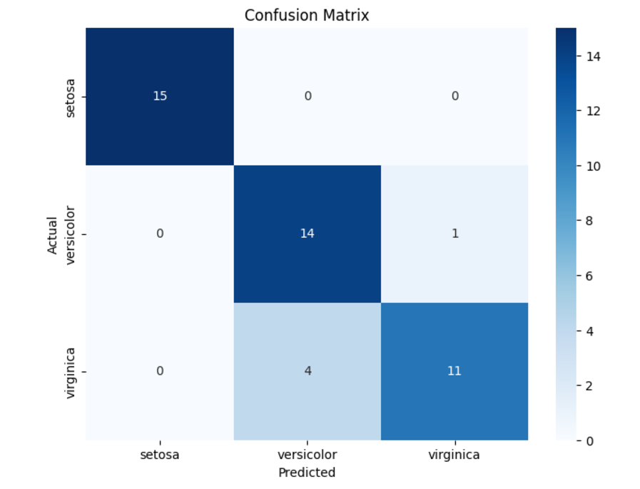

5. Hyperparameter Tuning
Default parameters may not yield the best performance for a given dataset. By tuning the model’s hyperparameters, we can optimize its accuracy and generalizability.
Key Parameters to Tune
- n_estimators: The number of trees in the forest.
- max_depth: The maximum depth of each tree.
- min_samples_split: The minimum number of samples required to split an internal node.
- min_samples_leaf: The minimum number of samples required to be at a leaf node.
We use GridSearchCV to systematically explore combinations of these parameters.
Tuning Process
GridSearchCV performs cross-validation to evaluate each parameter combination, selecting the one that yields the best results.
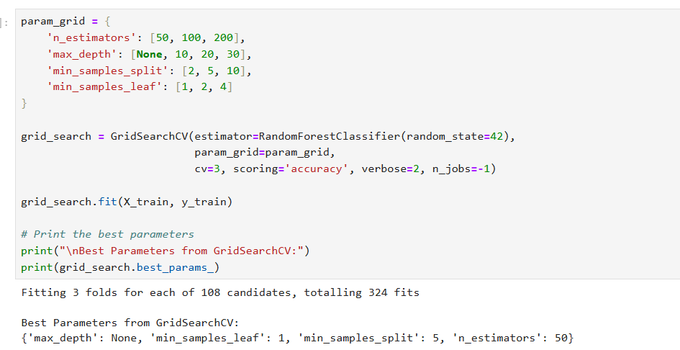
Results
The optimized parameters are applied to train a new Random Forest model, resulting in improved performance metrics.
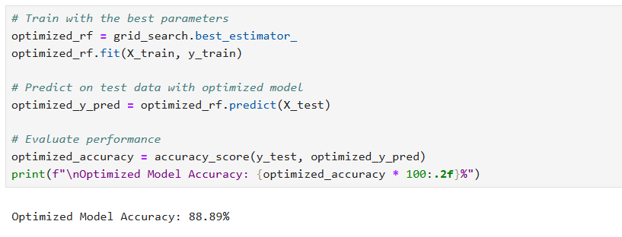

6. Feature Importance
Random Forest provides a measure of feature importance based on how much each feature contributes to reducing impurity in the trees.
Visualization
A bar chart is created to display the relative importance of each feature. For the Iris dataset, petal length and petal width typically rank as the most influential features.
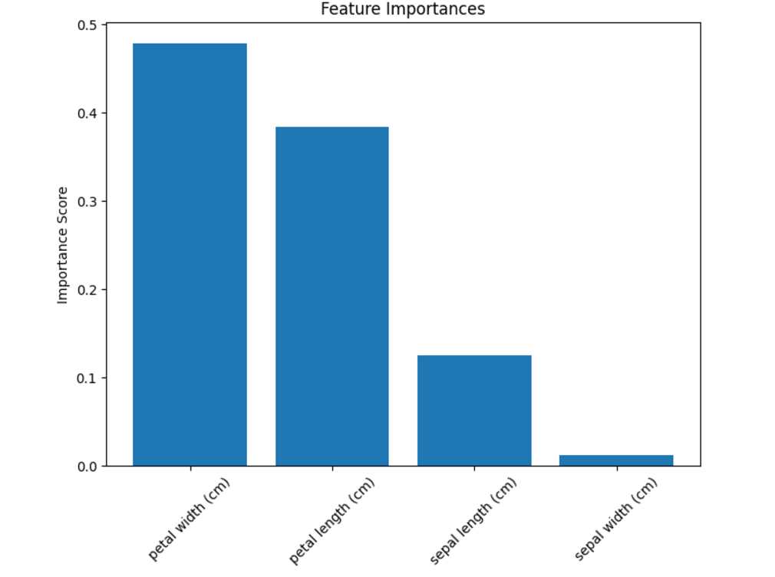

7. Visualizing Decision Boundaries
To understand how the Random Forest model separates different classes, we visualize decision boundaries using two features (e.g., petal length and petal width). This helps us see how the model distinguishes between species in a 2D space.
Steps for Visualization
- Select two features for simplicity.
- Create a mesh grid that spans the feature space.
- Predict the class for each point in the grid.
- Plot the decision regions along with the actual data points.
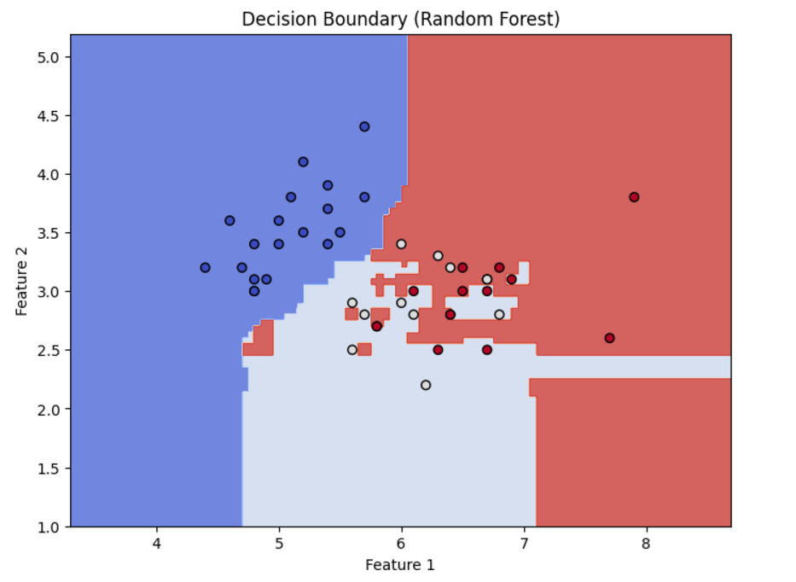

8. Model Evaluation
After tuning the model, we compare the baseline and optimized versions using the following metrics:
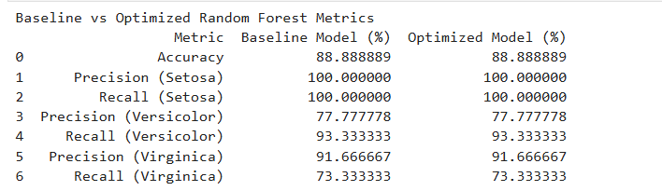

9. Conclusion
Key Takeaways
- Random Forest is a reliable and flexible algorithm suitable for various tasks.
- Hyperparameter tuning significantly improves performance, making the model more accurate and generalizable.
- Feature importance analysis provides actionable insights, helping refine data preprocessing and feature selection.
- Decision boundary visualizations enhance interpretability, enabling a deeper understanding of the model’s behavior.
Applications of Random Forest
- Healthcare: Disease prediction and patient segmentation.
- Finance: Fraud detection and credit risk assessment.
- Environmental Science: Land cover classification using satellite imagery.

10. Next Steps
To build on this knowledge, consider:
- Applying Random Forest to new datasets (e.g., from Kaggle).
- Experimenting with other ensemble methods like Gradient Boosting or XGBoost.
- Exploring advanced feature engineering techniques and validation strategies.

References
- Breiman, L. (2001). Random Forests. Machine Learning, 45(1), 5–32. doi:10.1023/A:1010933404324
- Pedregosa, F., et al. (2011). Scikit-learn: Machine Learning in Python. Journal of Machine Learning Research, 12, 2825–2830. Retrieved from https://scikit-learn.org
- Medium Blog. (n.d.). A Visual Explanation of Random Forests. Retrieved from https://medium.com
- Fisher, R. A. (1936). The Use of Multiple Measurements in Taxonomic Problems. Annals of Eugenics, 7(2), 179–188. doi:10.1111/j.1469-1809.1936.tb02137.x

